**Need a duplicate PO removed /deleted/cancelled from WTS**

**Ticket No: - INC**0864643

**Issue Description: -**

* Need a duplicate PO removed from WTS PO#569292.
* Duplicate PO from the DC needs to be cancelled/removed asap as inventory is this weekend. WHS 215.

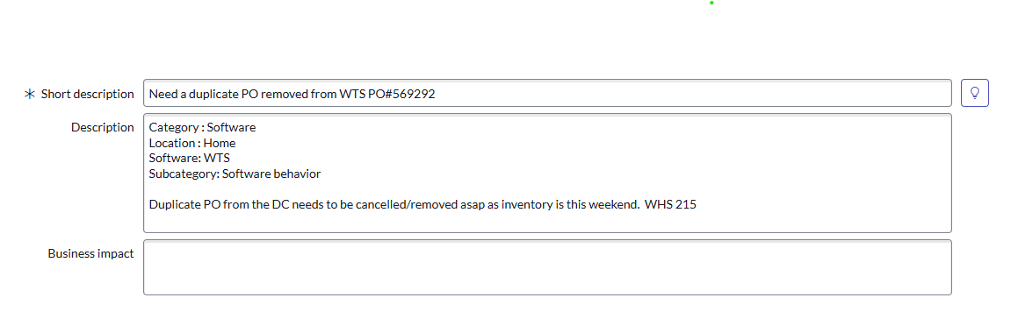

**Steps for investigating, analyzing & resolving this issue.**

1. Check the status in Korber.
2. Check the TransferOrderStatus in WTS.
3. Check the status in SV2/ESL

**Check the status in Koerber by executing below query:**

**Query: -** select status, * from t_order where retail_po_number='569292';

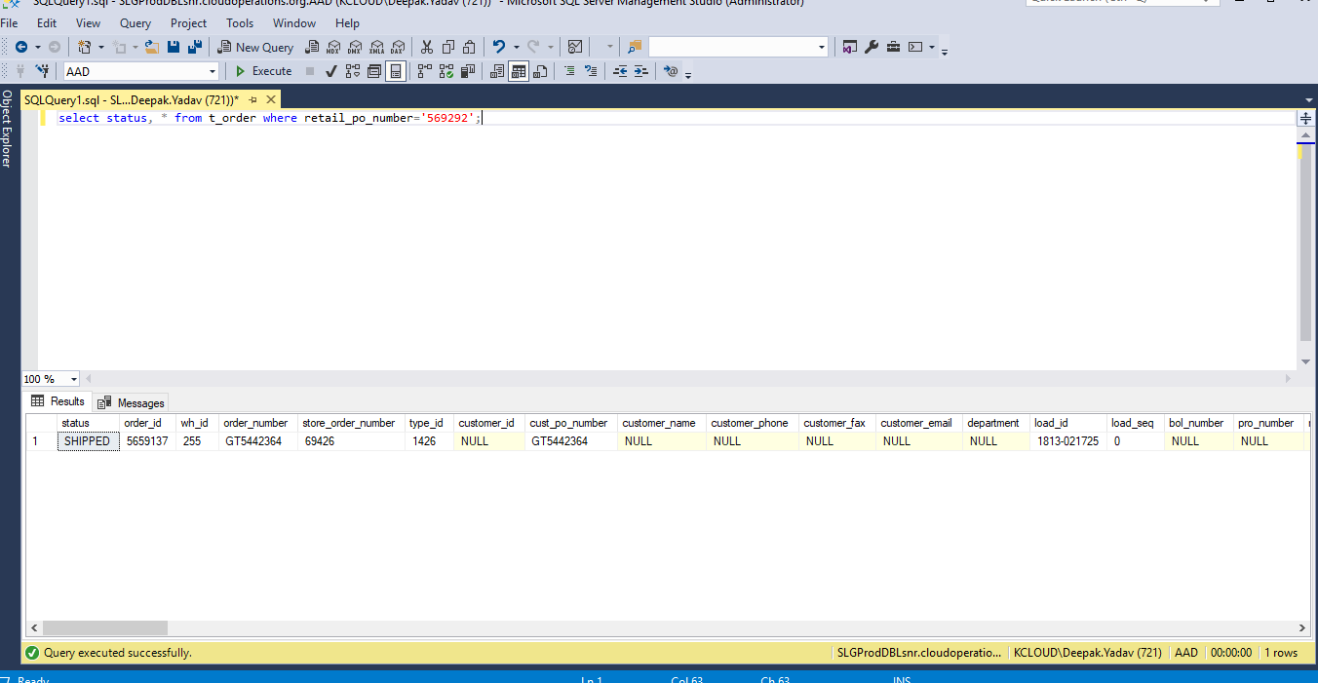

**Check the TransferOrderStatus in WTS by executing below query:**  
  
 SELECT LocationNumber, *

FROM [WMS_Reporting].[Inventory].[TransferOrder] tom (NOLOCK)

JOIN [Inventory].[TransferOrderLine] tod (NOLOCK) ON tod.TransferOrderGUID = tom.GUID

JOIN [Common].[Location] loc (NOLOCK) ON loc.ID = tom.DestinationLocationID

JOIN [Common].[Item] item (NOLOCK) ON item.ID = tod.ItemID

WHERE tom.OrderNumber in (

'GT5442364'

) AND loc.LocationNumber = '06193'  
  
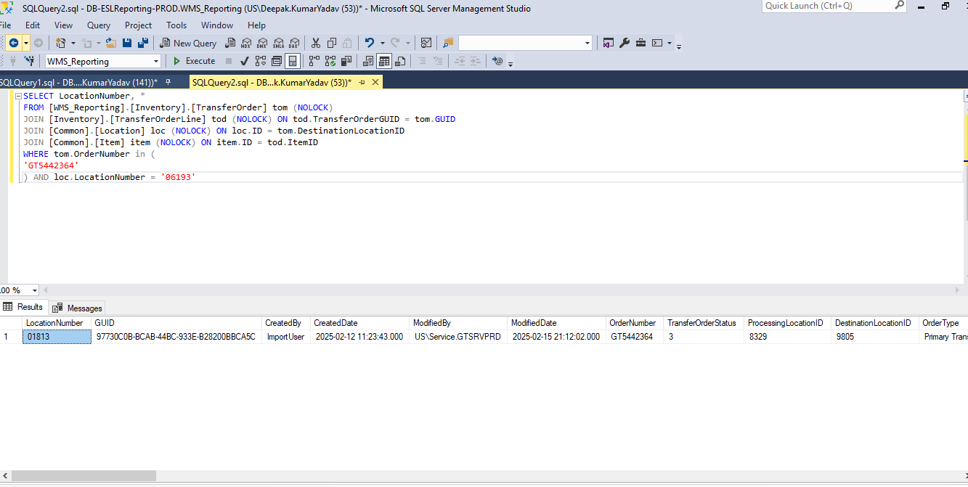

**Check the Status in SV2/ESL by executing below query:**

SELECT

po.CreatedBy,

po.ID,

po.PurchaseOrderNumber,

po.CreatedDate,

po.ModifiedDate,

po.RequestedDeliveryDate,

po.Status,

po.OrderDate,

po.PurchaseOrderType,

loc.LocationNumber,

loc.SupportingLocationNumber,

pod.QuantityOrdered,

pod.QuantityReceived,

pod.QuantityCancelledPending,

pod.QuantityCancelled,

pod.QuantityCancelledConfirmed,

pod.LineNumber,

itm.SafelitePartNumber

FROM [ESL_Reporting].[Inventory].[PurchaseOrder] po (NOLOCK)

JOIN [Inventory].[PurchaseOrderDetail] pod (NOLOCK) ON pod.PurchaseOrderID = po.ID

JOIN [Common].[Location] loc (NOLOCK) ON loc.ID = po.LocationID

JOIN [Common].[Item] itm (NOLOCK) ON pod.PartOrderedID = itm.ID

WHERE loc.LocationNumber = '01813'

AND po.PurchaseOrderNumber in (

'569292'

)

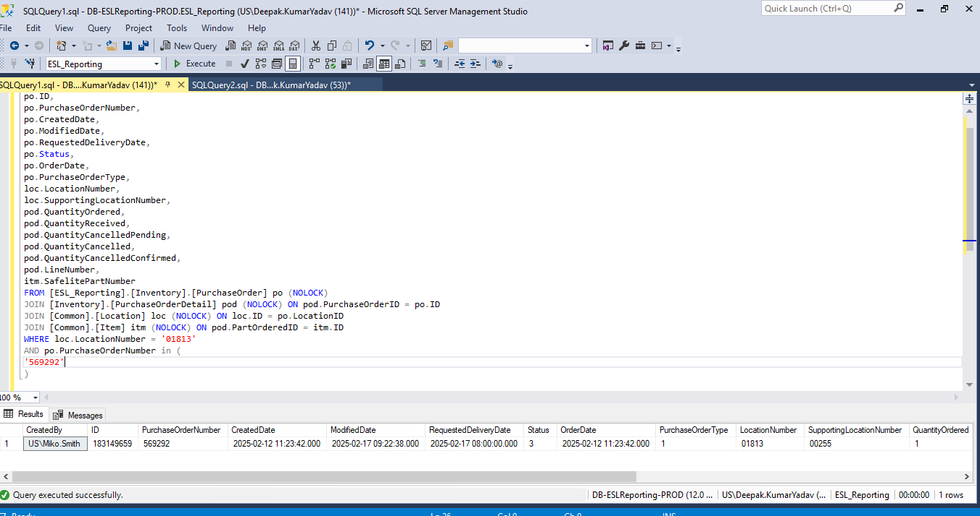

**Conclusion / Result : -**

Checked the given PO#569292, It had been already shipped from Koerber in WHS 255 and have checked in SV2 and WTS, the given PO had been completed and received. There is not any duplicate order that has been attached found with given PO.

**Update the Caller:-**

**Work Note: -**

Hi @Randall Updike, we have checked the given PO#569292 had been already shipped from Koerber in WHS 255 and also, we have checked in SV2 and WTS. The given PO had been completed and received. There is no any duplicate order has been attached with given PO. Below is the attached for your reference. If you have any query , Please let me know.

